Alcoholics Anonymous Meetups Report

The Hindu Newspaper is second most circulated English-language newspaper in India. Since 2006 Their website publishing the articles on Alcoholic Anonymous which is approximately (~11,842) and in which Meetings Schedules conducted by Alcoholic Anonymous articles is approximately (~11,191). The Hindu Newspaper is my primary choice of resource for the Data Extraction part.

The tools used for data extraction as follows

1. BeautifulSoup4
2. Pandas

Extracted information

* Headline
* Description (lead paragraph)
* author's name
* publication date
* main content (textual)

Python Dependencies Installation

* pip install beautifulsoup4
* pip install pandas
* pip install matplotlib
* pip install plotnine

Getting Started

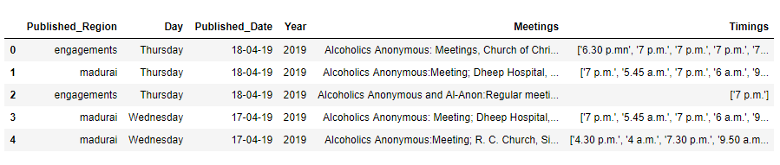The collected data undergoes data pre-processing and filtering features needed for the Analysing the Alcoholic Anonymous Meetings. The Final Data will like below

Categorizing the Data in terms of time intervals 2006 – 2019. During these thirteen years theirs a continuous decrease in schedule of AA Meetings.

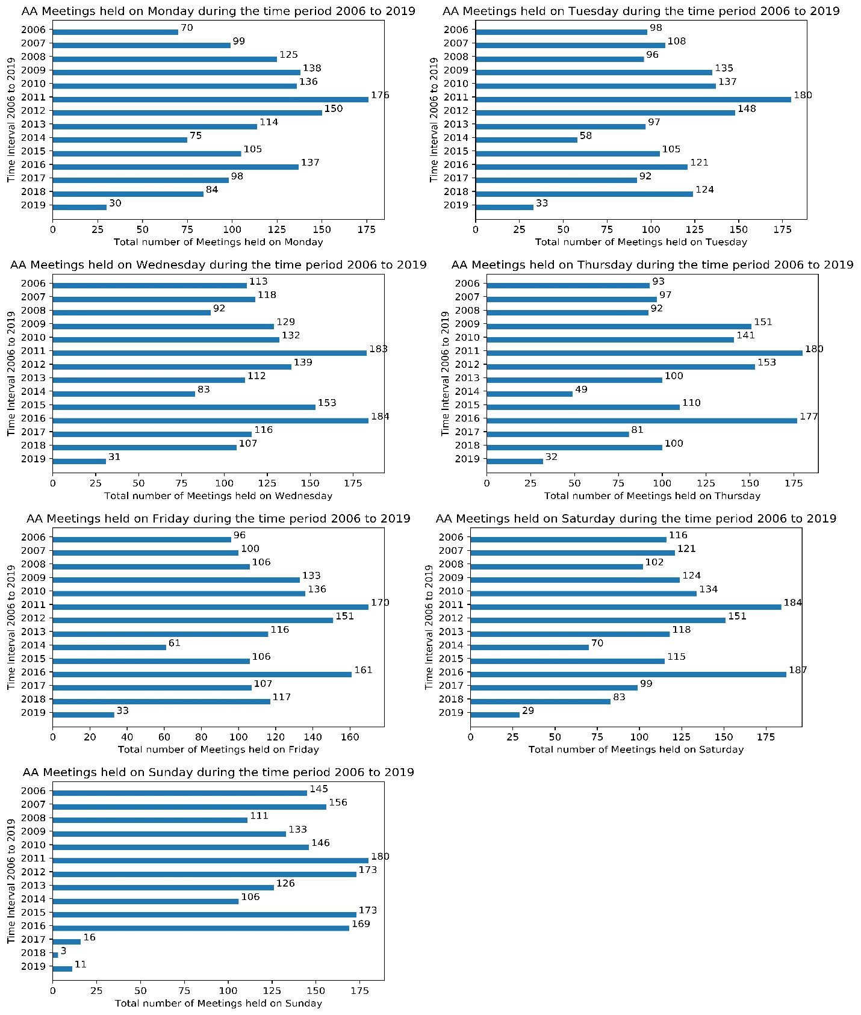Visualizing total number of meetings scheduled which decreased continuously during weekdays.

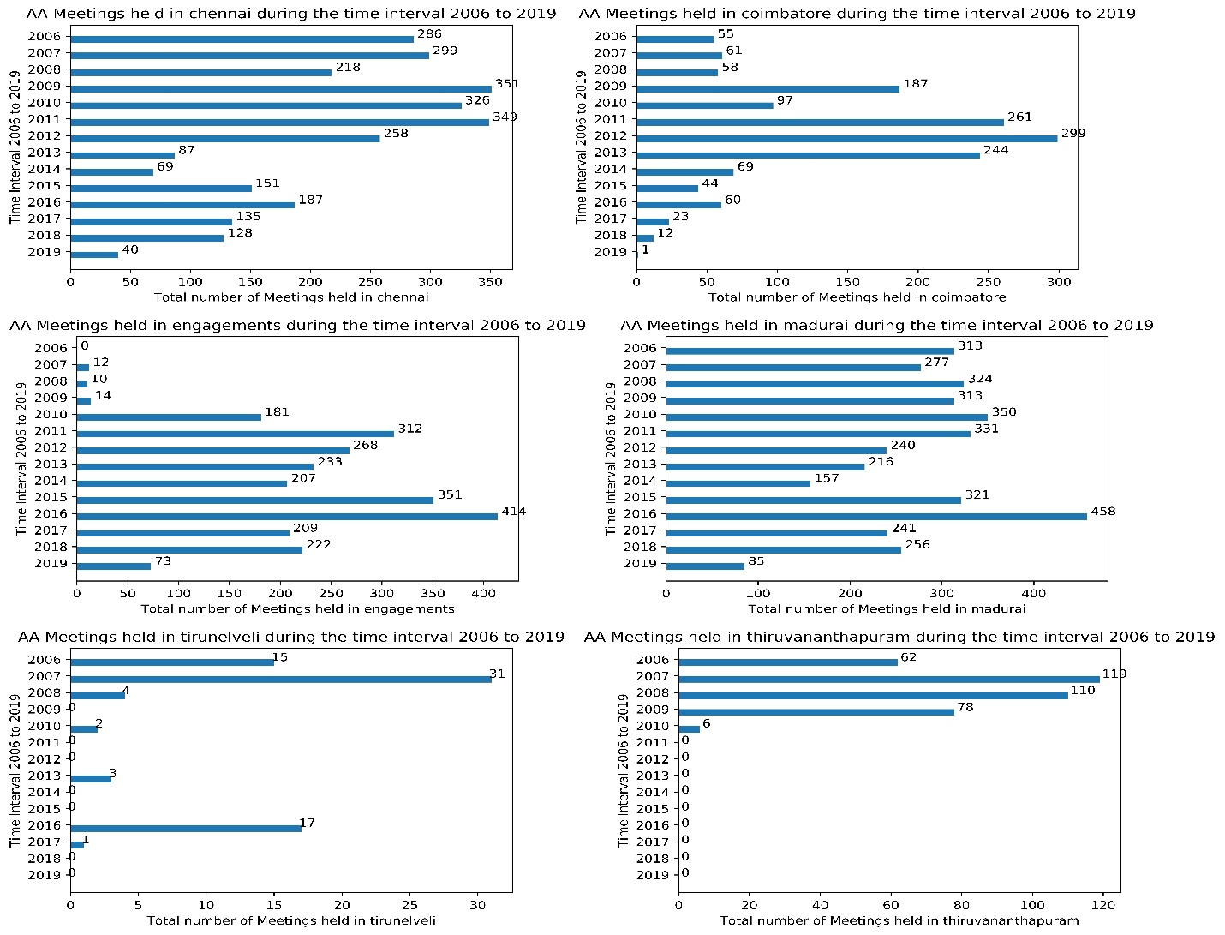 Visualizing total number of meetings scheduled which decreased continuously during locations.

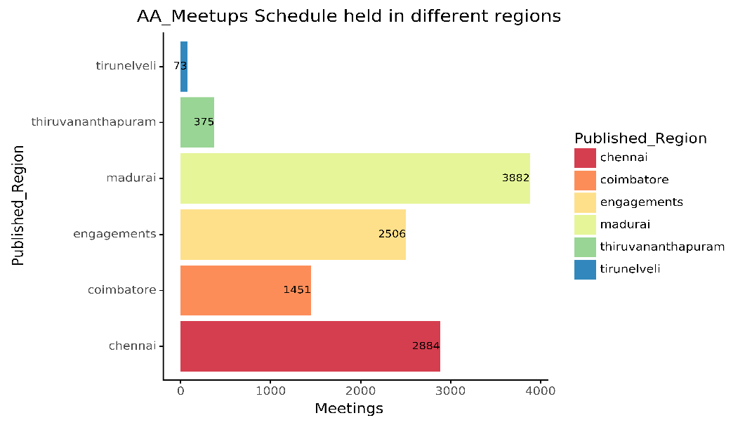Visualizing Total number of meetings held during the time-interval (2006 - 2019) in the southern India

Summary:

I don’t find any reason for fall of AA meetups. If we are able gather the main cause behind the continuous fall on Alcoholic Anonymous meetups during these thriteen years. We can come to a conclusion the about the AA treatment in India.

Code and Dataset

* The Hindu.ipynb (Data Extraction Code)
* The_Hindu.csv (Extracted Dataset)
* Data pre-processing.ipynb (Code for filtering the parameters from ‘ ‘The_Hindu.csv’ required for Data Visualization on AA_Meetups)
* AA_Meets.csv (Final Dataset)
* AA_Meetings_Analysis.ipynb (Above Visualization Code)
* AA_Meetups_Schedule_by_Regions.ipynb (Meetings held in southern India)